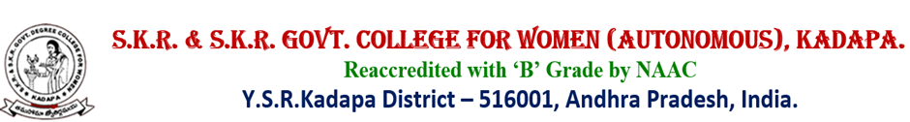

DEPARTMENT OF MATHEMATICS

BEST PRACTICES

Department of Mathematics sponsored Meritorious awards to the merit students on the occasion of National Mathematics Day celebrations on 22.12.2021.

Department of Mathematics organised National Mathematics Day celebrations on 22-12-2021. Principal Dr P.Subba Lakshumma, M.Com,,M.Phil.,Ph.D inaugurated the meeting by lighting the candle. The programme was started with prayer song. Principal explained in detail about the life history of Srinivasa Ramanujan.

Dr S. Nagendra, Lecturer in Mathematics, Govt College for women(A), Kadapa attended as chief guest and delivered the contributions of Srinivasa Ramanujan in Mathematics and beauty of Mathematics through PPT presentation.

Smt L. Sudheera, Vice principal explained the job opportunities after completion of B.Sc Mathematics course.

Sri Dr P. Gurivi Reddy, incharge of Department of Mathematics said that everyone should improve the Mathematical skills to achieve the success in their lives.

Dr G. Swaroopa, Kum K.Shalini, Smt K. Sunitha department of Mathematics faculty focussed on Importance and applications of Mathematics in everyday life.

